**7: Create NodePort Service with YAML and Access Application via Browser**

--- **note** – we are going to create a nodeport service and test it.

**Create NodePort Service for ReplicaSet**

apiVersion: v1

kind: Service

metadata:

  name: replicaset-nodeport-service # this is name of the service.

spec:

  type: NodePort

  selector:

    app: myapp2

  ports:

    - name: http

      port: 80

      targetPort: 80

      nodePort: 31232

**Create NodePort Service for ReplicaSet & Test**

**# Create NodePort Service**

--- **kubectl apply -f 03-replicaset-nodeport-servie.yml**

**# List NodePort Service**

--- **kubectl get svc**

**# Get Public IP**

--- **kubectl get nodes -o wide**

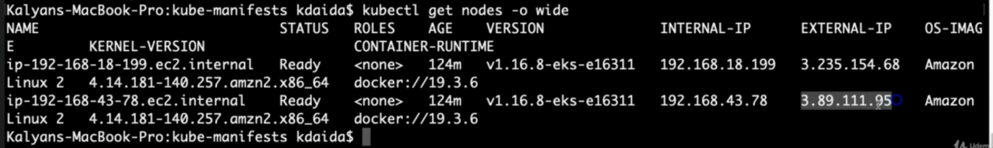

**# Access Application**

--- **http://<Worker-Node-Public-IP>:<NodePort>**

--- **http://<Worker-Node-Public-IP>:31232**

**API References**

--- **ReplicaSet**: https://kubernetes.io/docs/reference/generated/kubernetes-api/v1.18/#replicaset-v1-apps